# Why is a Last Mile network such a complex but also vital issue in Networking and Communications?

Since the goal is to connect end-users to ISPs, it’s essential to consider the unique geographical and economic factors that shape different communities and their environments.

For example, an approach that works well for an end-user in an Australian metropolitan may not be as effective in India. Take trenching, for instance, while expensive, the process of deploying fibre in Australia is well-structured and widely implemented. In contrast, in India, securing permissions is a major challenge due to dense populations, traffic and bureaucratic hurdles [1]. The slow approval process often pushes companies to opt for aerial deployment in many parts of the last-mile network. However, aerial cables are highly vulnerable to environmental factors, with even moderate to heavy rainfall or strong winds frequently causing disruptions and noise interference. The rate at which the infrastructure is developing is unable to keep up with the ever increasing internet demand of an over populated developed nation.

In rural Australia, end-users are often located far from exchanges, making last-mile deployment significantly more costly due to terrain, distance, and the environment. Maintenance and repairs are equally or more difficult and expensive [2]. This would also require a lot of skilled workers who need to be trained in various fields. So developing the last mile network would also involve creating systems that help people contribute better. This obviously requires a lot of money[2]. But it is not all gloom, for example, NBN has and is set to make a lot of progress when it comes to wireless delivery in these areas. With most regional homes set to benefit from max download speeds of 250 Mb/s and max upload speeds of 20 Mb/s under the “Fixed Wireless Home Fast” plan. And max download speed of 400 Mb/s and max upload speeds of 40 Mb/s under the “Fixed Wireless Home Superfast” plan. But these come with limitation of low upload speed, high latency, reduced data rate and poor service. It makes activities like gaming and HD video conferencing impractical. Even when FTTN (Fiber to the Node) is available, the cables and machinery are degrading, performance suffers sharply with distance, and it’s common for end-users to be more than 5 km(Copper would be useless around 4km) from the nearest node, severely impacting speed and reliability [2].

Urban areas in Australia, on the other hand, face a different set of challenges. Many networks still rely on aging infrastructure, requiring constant maintenance and upgrades. In some ways, rural areas might have an advantage, as they bypass the trial-and-error phase of determining feasible solutions[2]. They usually get what is proven to work in the city or their options are predefined by geographical and technological constraints. In urban areas, things work by collaboration of multiple government and private agencies. For example, in areas where the NBN only has wireless and satellite connectivity, Telstra is required to maintain their existing copper lines for telephone service[2]. This obviously requires a lot of money which paid to Telstra by the NBN. And Telstra would have to keep doing this until NBN replaces their copper with NBN Fiber. Sustaining these partnerships is essential for updating infrastructure in urban areas. Apart from this, the NBN also needs to address the problem of outages, network capacity and backups. For example, 88% of the network issues during bush fires were due to the lack of power[2]. Even technologies like Fixed Wireless which work well in sparse areas suffer from congestion in cities, with data transfer rates slowing down significantly during peak hours, impacting overall connectivity and user experience. Basically, there is no one shoe fits all sizes type of solution.

Developing the last mile network would require an understanding of all of these and many more factors. A team well versed with the geographical, economical and even cultural challenges unique to each deployment site is the bare minimum in my opinion. And even then, it might not be enough and a lot of work would end up happening on a “trial and error” basis.

# What are the main, typical, options for delivering Last Mile networks in Australia, NBN or otherwise? [4 marks]

The National Broadband Network (NBN) is a government owned broadband provider to improve internet access across Australia. It is responsible for majority of the last mile infrastructure that is and that will be. There are other players, private fibre network providers, Fixed wireless and satellite providers.

The NBN approach is as follows:

1. **Fibre to the Home (FTTH)**

Direct fibre to the user.

1. **Fibre to the Node (FTTN)**

Fibre from exchange to a node in a reasonably dense area. The node then connects to end user via existing copper(telephone, VDSL2) lines.

1. **Fibre to the Kerb/Curb(FTTK/C)**

Fibre from exchange to some device on the street, typically the user is responsible to run the copper from the device to their house to access the network. Kerb to home is via VDSL2.

1. **Fibre to the building(FTTB)**

Fibre to a building(Apartment, hospital, etc), from there the owners are typically responsible for facilitating a copper lines that connect to each unit.

1. **Hybrid Fibre Coax(HFC)**

Fibre from exchange to an optical node, from there, a shared coax copper cable runs across the entire neighbourhood/street making it a shared medium. Although not universal, it remains significant because both the NBN and private providers (such as Telstra) invested heavily in this architecture to take advantage of existing cable infrastructure [3].

1. **Fixed Wireless**

When fibre deployment is not possible. For rural, remote or difficult terrain areas. Signal sent from a high tower(antenna) with clear line of sight to the destination. Each premise that subscribes to this service has an receiver antenna that receives the signal from the tower. The receiver is connected to an NBN supplied indoor unit called a Node Termination Device(NTD). The unit is the point where the NBN network ends(NBN not responsible beyond this point). The user’s modem connects to the NTD via a cable. These cables are typically VDSL2/Coax copper[4].

1. **Sky Muster Satellite**

For properly remote locations. Customers from Tasmania and from remote islands (Norfolk, Christmas). Two satellites are used to provide internet to the end user[5].

The notable alternative players provide a privatised service for the same carriers mentioned above.

1. **Private FTTP Networks**

companies like TPG, Opticom and Aussie broadband provide direct fibre to the user.

1. **5G Broadband(Mobile Wireless)**

Alternative to fixed wireless from NBN. Telstra, Optus, etc are major providers.

1. **Satellite Internet(Not Australian but worth mentioning)**

Currently, Starlink uses low orbit satellites for the service with latency lower than sky muster satellite from NBN.

1. **Fixed Wireless ISPs**

Some companies provide their own p2p wireless infrastructure. One really good(or bad) example of this is Reliance Jio in India.

# What are the actual technical (physical) limitations on data-rates across the various Last Mile network technologies? [3 marks]

1. **DSL, VDSL2, ADSL2+**

The further the signal has to travel, the more it attenuates. Cross talk and noise also limit the bandwidth. Higher frequency data transfer not feasible. More suitable for sending data downstream than upstream. Much lower upload than download.

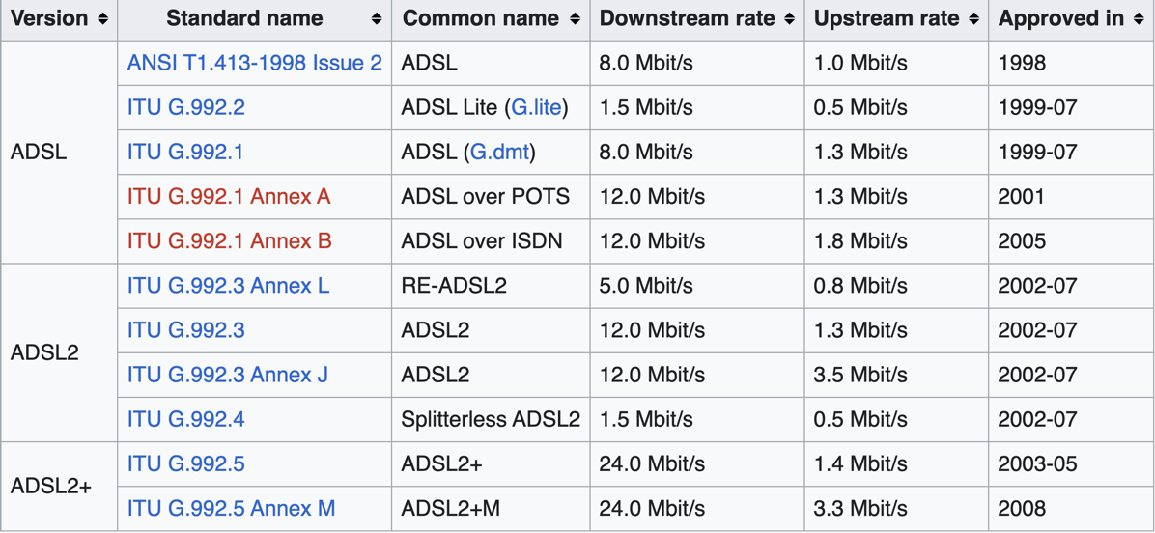

https://en.wikipedia.org/wiki/ADSL

Bandwidth(DSL): 5 kHz t to ~1.1 MHz

Bandwidth(ADSL2+): 5khz to ~2.2 MHz

Bandwidth(VDSL2): 5khz to ~30Mhz

Max Download Speed: 24 Mb/s

Max Upload: 3 Mb/s

1. **FTTP**

Fibre does not allow multiple users to tap into the same line, unlike copper. Point to point deployments from exchange to every possible the end user would amount to millions of kilometres of fibre. And that fibre needs to be laid underground and would also require maintenance and repair. This is why it is financially and practically impossible to only use FTTP for last mile.

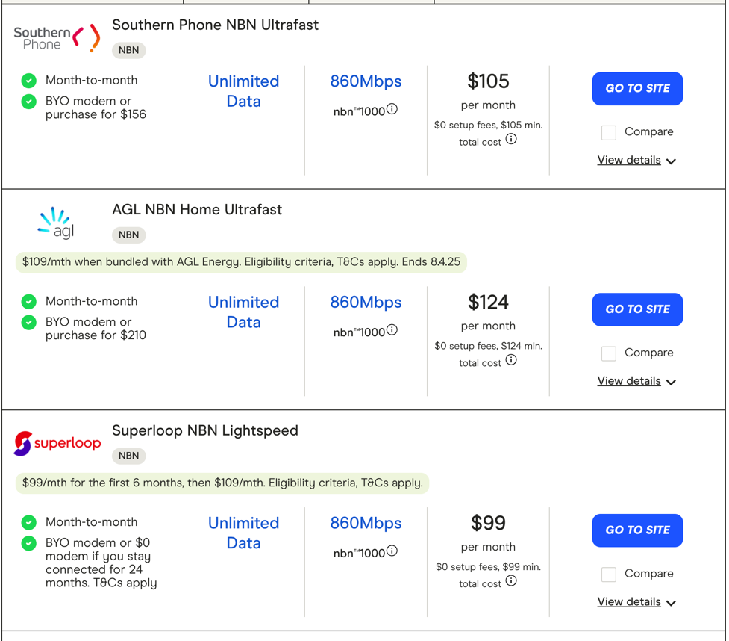

Theoretical Max Download: 100s of GB/s

Theoretical Max Upload: 100s of GB/s

offered Download: 50MB/s - 1GB/s,

offered Upload: 50MB/s - 1GB/s (mostly symmetric)

1. **FTTN**

The existing copper lines that it relies on lose signal strength over distance. Copper also resists higher frequency signals, limiting the range of frequencies that can be reliably transmitted without significant attenuation. Copper is also an antenna, so it is going to pick up noise from other cables and surroundings.

Copper wires also cannot cater to high speed 2 way data transmission. The VDSL2 lines were designed for voice calls rather than data. So we get decent download speeds and much worse upload speeds due to the way copper carries electric signals. It is actually really convenient that we are able to get decent download speed from them because they were originally used for a different purpose.

Adding to what was mentioned above, due to signal loss over time, a copper wire can only reliably carry a signal for about 4km. The degradation over distance is as follows:

Bandwidth: 0~30Mhz

Download: 1-100Mb/s

Upload: 1-40Mb/s

These are theoretical best, real performance is worse due to wire length, noise, other issues.

1. **FTTK/C**

Not as good as FTTP because it still uses copper lines(VDSL2) to connect from the kerb to the user’s device.

Bandwidth: 0-30Mhz

Download: 1MB/s-100MB/s

Upload: 1-40MB/s

These are theoretical best, real performance is worse due to wire length, noise, other issues.

1. **HFC**

The upload speed is less than download speed because the optical node is connected to the users via a shared coax cable. And because coax cables are better suited for downstream signal flow anyway, that combined with congestion causes the upload speed to suffer. Download speeds might also suffer noticeably during peak hours.

BANDWIDTH: 54 MHz -1000 MHz

Download: 100MB/s – 1GB/S

Upload: 10MB/s-100MB/s

1. **Fixed Wireless**

Fixed wireless actually has many caveats.

It requires a clear Line of Sight from source to destination. So a huge mountain, hills, buildings or even trees might in between a user and a source tower might affect the signal.

The signal loses strength over distance. Towers typically cover up devices within a 14-15 km radius under NBN. But latency and connectivity issues at distances more than 8km are extremely noticeable.

Since all users are sharing the same bandwidth, there is high potential for network congestion. One must be wary of the difference between the bandwidth of the tower and the bandwidth that they can actually operate under which is much lower.

It is also extremely susceptible to weather conditions.

The upload speeds are also much lower because like coax, wireless also prioritises downstream signal flow. So gaming, and high quality video conferencing is still not very feasible on wireless.

Higher the frequency, more energy is required to transmit data. While theoretically possible to get better speeds, users typically get rates as mentioned below.

10Mhz – 20Mhz

Download: 25-75 MB/s

Upload: 5-20 MB/s

1. **Satellite**

Signals must travel a long distance and back. The major limitation is the latency. NBN sky muster is around 36,000 km away from the earth. The latency on Sky Muster is around 600-700ms. While it provides a great solution for remote users when it comes to essential tasks like email and browsing, the upload speeds are still very low and the video calls and gaming experience would still be very poor. This might change with more and more companies deploying lower earth orbit satellites. The latency of Starlink is much lower than NBN Sky muster.

The bandwidth available for use of satellite for the last mile is also quite limited. Only a fixed amount of frequency bands are available for satellite signal. There is also potential for congestion because the bandwidth is shared.

Extreme weather will also negatively impact satellite signal strength.

Download(Sky Muster): 25MB/s-100MB/s

Upload(Sky Muster): 3MB/s-20MB/s

# LAST MILE DESIGN

1. Wired approaches
2. FTTN Simple: Here is a detailed explanation of this **FTTN Simple** approach.

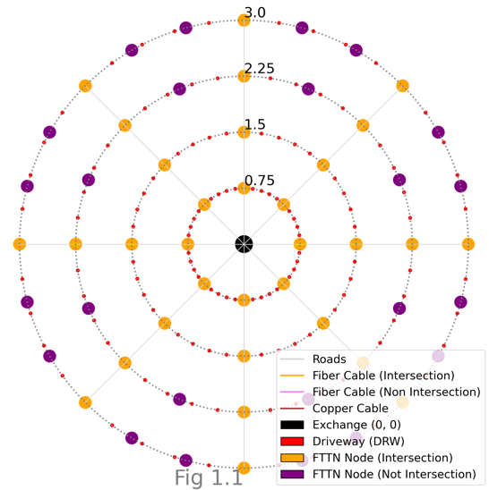

As you can see in the graph(Fig1.1), The exchange is represented by the black node. The FTTN nodes at the intersection of the roads are represented by the orange. The purple nodes are FTTN nodes equidistantly placed across each segment. (one per segment in 3rd ring and 2 per segment in 4th ring)

There is a p2p Fiber cable from exchange to every single FTTN Node(Intersection and Non Intersection). (The connections are along the road, but curved for the sake of display).

(As many Fiber cables as FTTN intersection nodes)

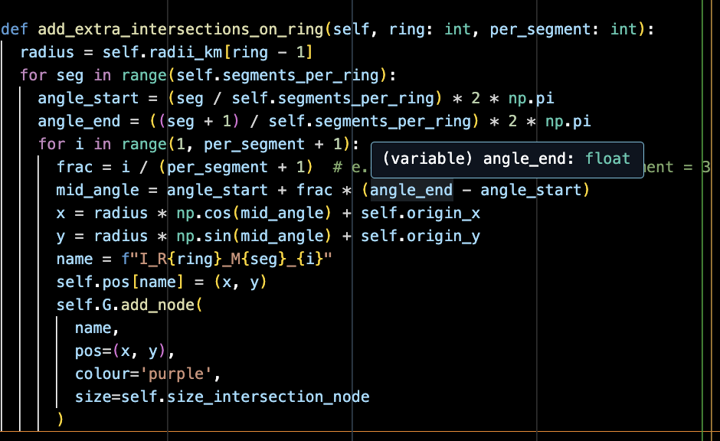

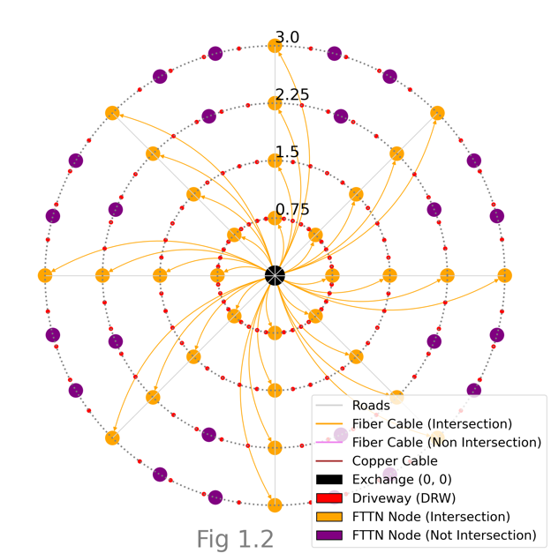

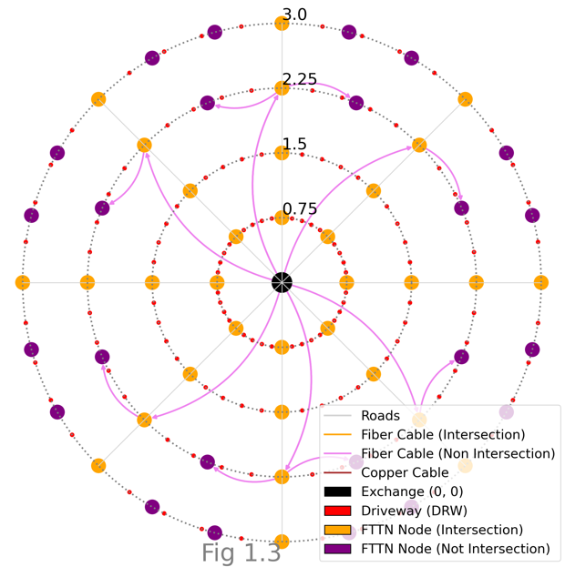

Let’s observe Fig 1.3. Shows Fiber connections from exchange to non-intersection FTTN nodes(purple) in the 3rd ring. The Fiber cable goes through the intersection(orange) and then connects to the closes non intersection FTTN node.

(As many Fiber cables as FTTN non intersection nodes on the third ring)

The purple Fiber cable does not connect to the orange node, just goes through that location.

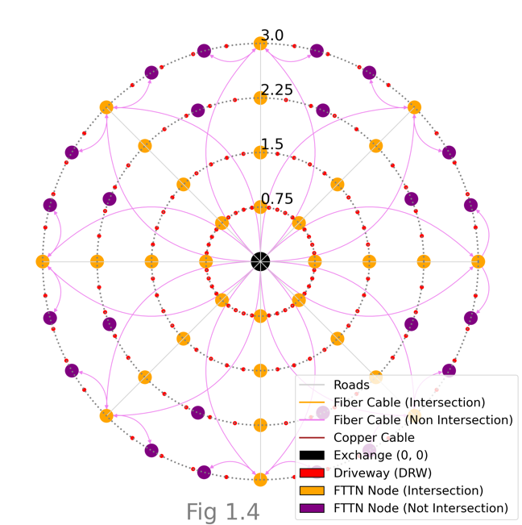

Fig 1.4 shows Fiber connections from the exchange to the 4th ring’s non-intersection FTTN nodes(purple). For each non-intersection FTTN node, the Fiber goes through the orange node and then the closest non-intersection node that is not connected to the exchange.

As many Fiber cables as FTTN non intersection nodes on the 4th ring.

The purple Fiber cable does not connect to the orange node, just goes through that location

Finally, copper cables are used to connect the driveways to the exchange.

For each driveway node(red), A copper cable is connected from the closest FTTN node.

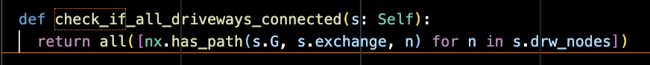

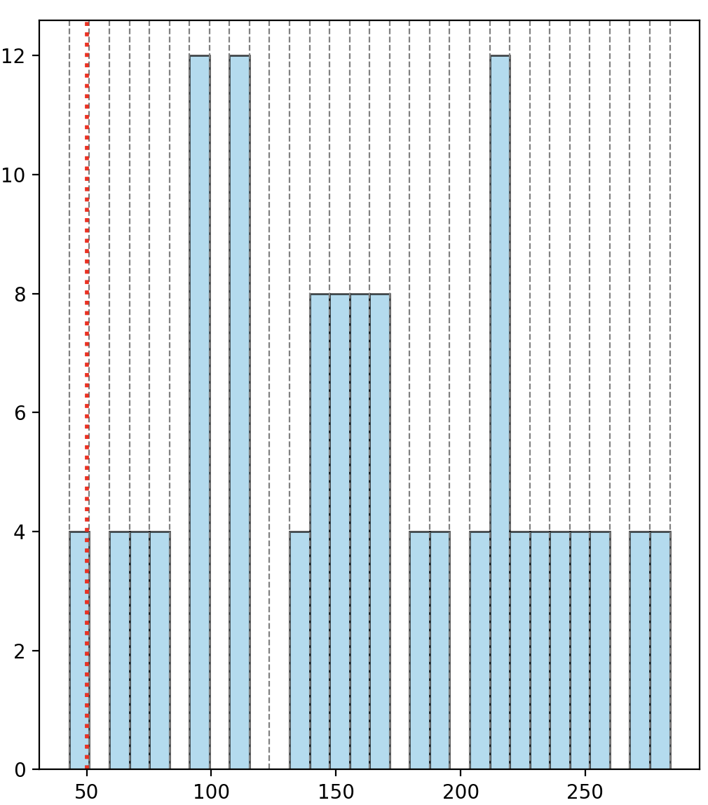

There are 4 drive way nodes with download speed less than 50 Mb/s.

This happens because of the second ring, the distance between copper cable and FTTN nodes is more than 600m in some cases.

(Currently using some decay factor to reduce speed such that speed is 50 MB/s at 600m)

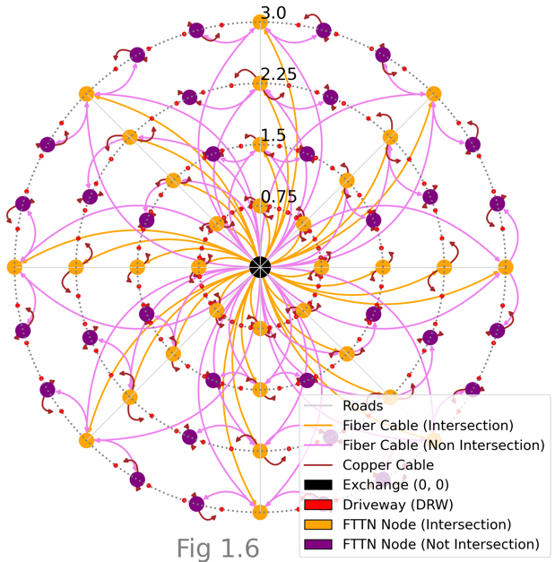

(Fig 1.6) After adding one extra FTTN node per segment on the second ring, all download speeds are above 50Mb/s.

Number of Driveway Nodes. : 128

Number of FTTN Nodes : 64

Fiber used in km : 158.52

Copper used in km : 24.74

Avg Download Speed in Mb/s : 179.01

Cost of Fiber(AUD) : 1585213

Cost of Copper(AUD) : 148490

Cost of Fiber Termination(AUD) : 19200

Cost of Copper Termination(AUD) : 19200

Total cost(AUD) : 1772104

Now, the cost is close to 2 million. But this is primarily because there are as many Fiber cables from the exchange. For the community of Bungenwood would require twice of that amount(3544208 AUD) because there are 2 big concentric circle groups. If anything, this approach shows the importance of splitting the cables. The network design would be as follows:

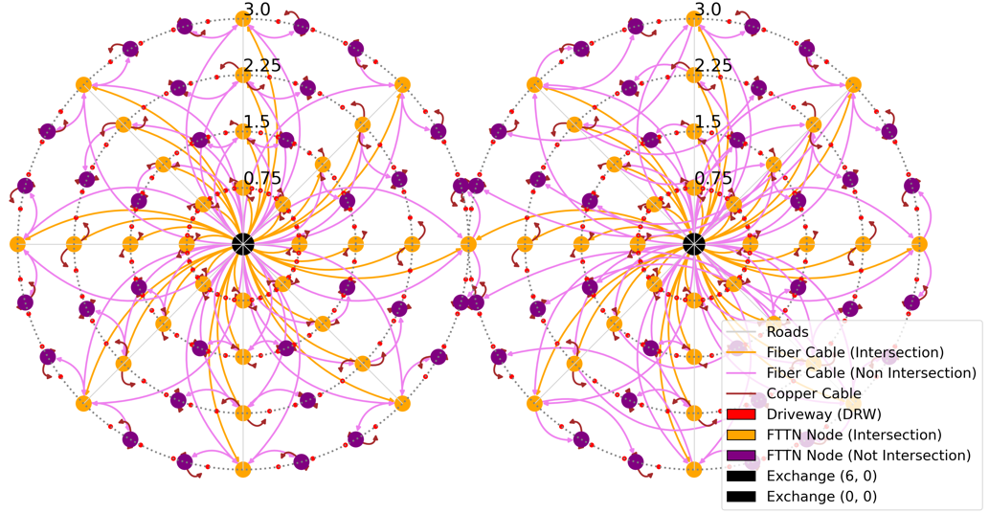

Number of Driveway Nodes. : 256

Number of FTTN Nodes : 128

Fiber used in km : 317.04

Copper used in km : 49.48

Avg Download Speed in Mb/s : 179.01

Cost of Fiber(AUD) : 3170426

Cost of Copper(AUD) : 296980

Cost of Fiber Termination(AUD) : 38400

Cost of Copper Termination(AUD) : 38400

Total cost(AUD) : 3544208

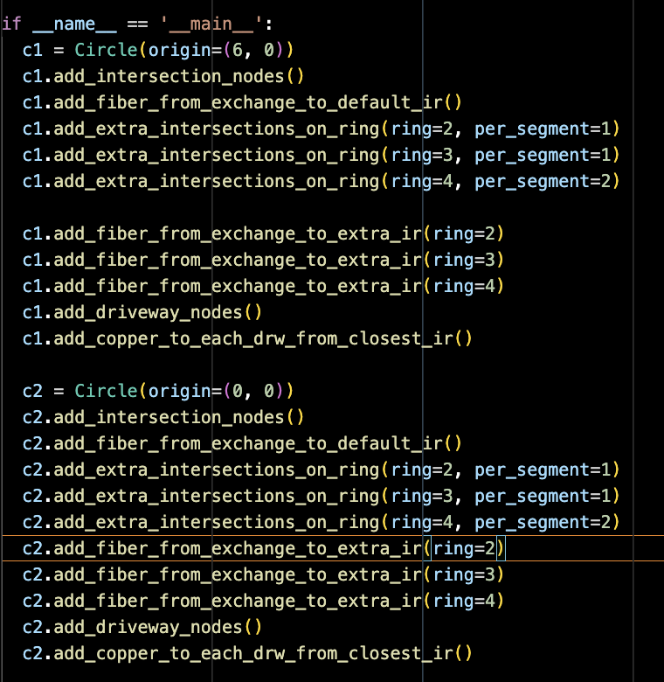

While this was ridiculously expensive, I don’t believe a lot of money would be needed to maintain this. No need to split Fiber, not many connections from FTTN node to the premises. Very little chance of congestion.

1. Better FTTN

We will split the Fiber at each intersection node.

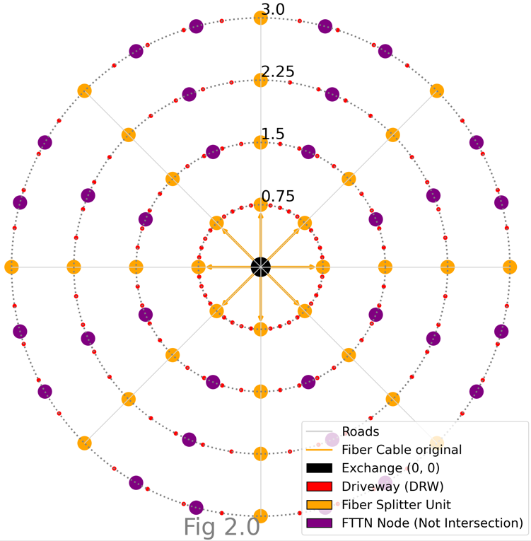

First, orange nodes are Fiber Splitter units that split the Fiber cable into multiple Fiber cables.. First, send Fiber from exchange to the splitters in the next ring.

The splitters are used to send a Fiber cable from one splitter to the closest splitter to in the next ring. The original cable is orange. The ones after split are in purple.

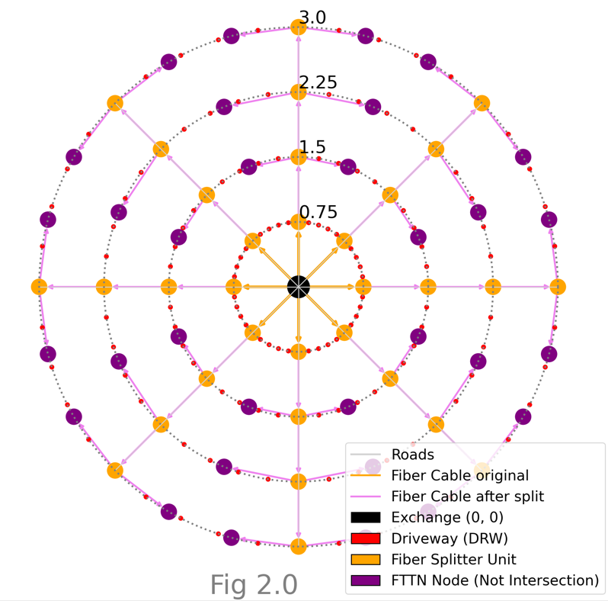

From each splitter, Fiber cables are sent to connect to FTTN nodes.

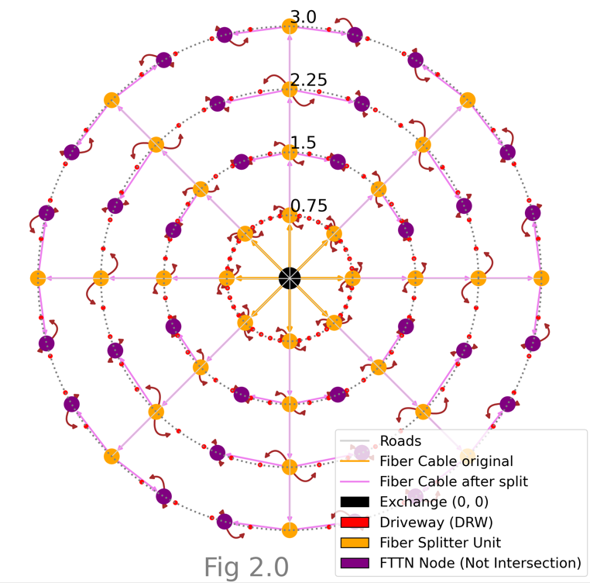

Finally, copper lines added from FTTN to the driveway. The speeds for each home would be the same. The major reduction is in the amount of Fiber cable being used.

There would also be additional costs for splitting the Fiber cables.

(1000 dollar per splitter node). The splitter can split one Fiber cable to 16 Fiber cable according to the question.

Total Fiber in km : 44.52

Total copper in km : 24.748

average download : 179.01

Total Fiber cost(AUD) : 445213.74

Total Copper Cost(AUD. : 148490.5

Fiber termination cost(AUD) : 19200

Copper termination cost(AUD) : 19200

Splitting cost(AUD) : 3200

Total cost(AUD) : 635304

f

Total cost for the new Bungenwood network using better FTTN is around 1.2 million AUD.

I think the wired approaches that were implemented show that either a wireless or a hybrid network is better.

1. **Wired Approaches**
2. Wireless mesh to mesh network is a really good option.

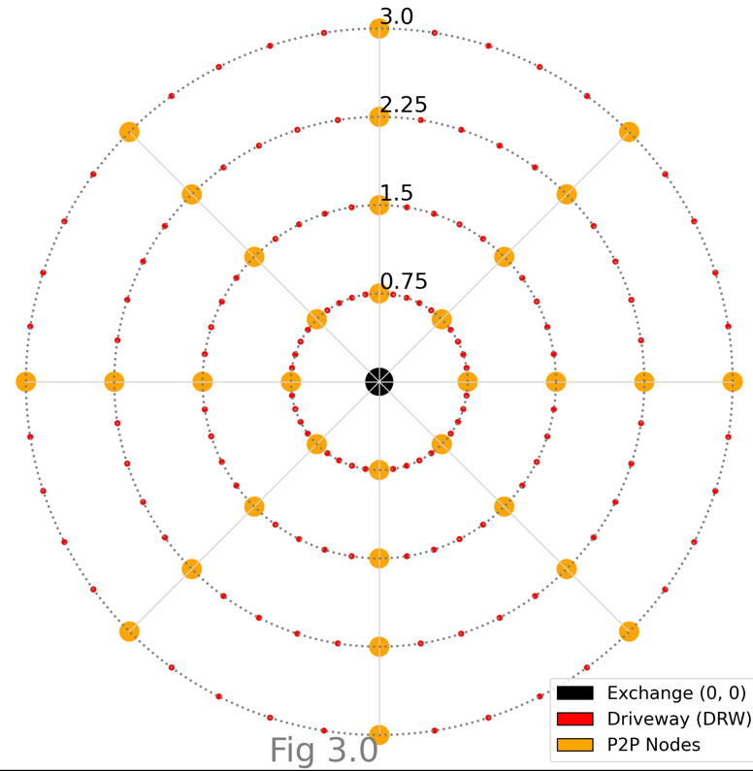

Yellow nodes are P2P links

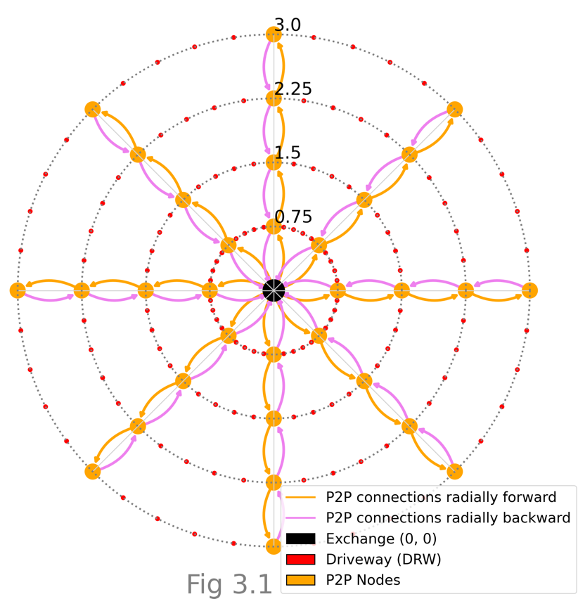

Link from a node to the next closest ring node in yellow.

Link from a node to the closest node in previous ring in violet

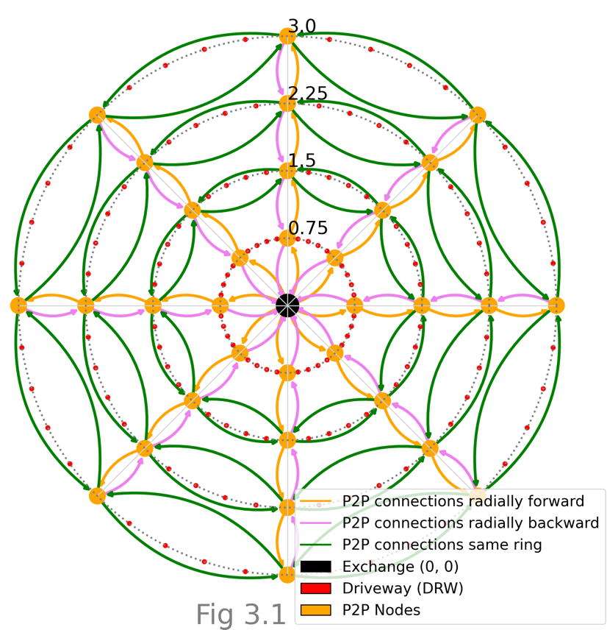

P2P links from node to closest ring node in green.

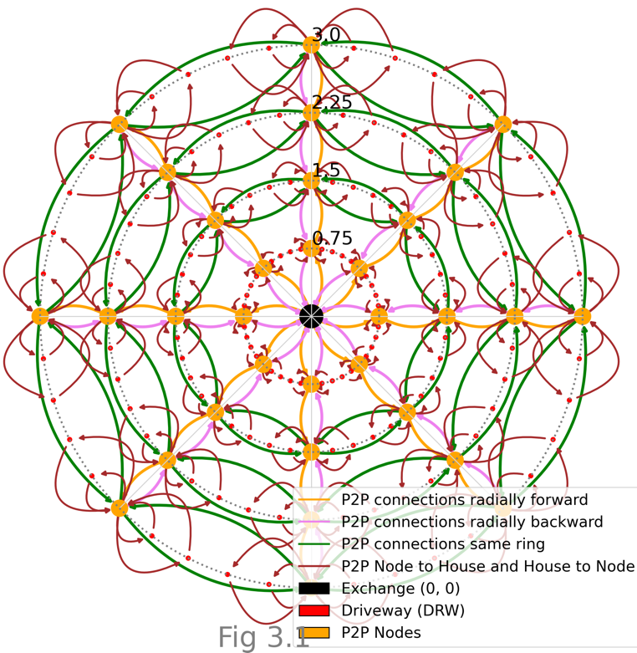

P2P links from node to house and house to node in red.

The number of P2P nodes is 32. So the cost of setting that up is

32 * 600 = 19200 AUD. The antenna costs 100, 000 AUD. Receivers for driveway cost 256 * 600 = 153600.

The total amounts to 272800 AUD.

For the Bundengwood community, the total would be 545600AUD.

There are many advantages to this approach. First, it is much cheaper than the previous approach I used. If the download speeds drop below 50MB/s, we can add intermediate nodes across the rings like we did in the wired approaches. I would have done an analysis of how much the speed changes as the number of houses per node decreases. But I have run out of time. The network is also easy to monitor, maintain and update compared to a wired approach. Of course, it is prone to weather, line of sight issues and other issues the plague the wireless approaches.

The other really good thing about this implementation is that I can see that every node has an eventual path to and from the exchange immediately.

Please check <https://github.com/thestochasticman/lastmile/tree/master> for more info.

1. **Hybrid Approaches**

There are some interesting ideas. Fiber to the intersection nodes and then a mesh for each segment of the ring?

# Reference

1. <https://www.defindia.org/wp-content/uploads/2021/09/Challenges-of-Last-Mile-Connectivity-Osama-Manzar.pdf>
2. <https://www.infrastructure.gov.au/sites/default/files/documents/rtirc-2024-nbn-co.pdf>
3. <https://www.nbnco.com.au/learn/network-technology/hybrid-fibre-coaxial-explained-hfc-3#:~:text=All%20types%20of%20nbn%20network,of%20the%20nbn%20network%20connection>.
4. <https://www.nbnco.com.au/learn/network-technology/fixed-wireless-explained>